Credit Matters Credit Concept Workshop
Presentation Script (Part II of II)
(Hand out quiz prior to presentation)
Opening Slide:
- Welcome back to the second presentation of the Credit Concepts Workshop series. Again, my name is __________ and I am a financial professional with___________.

I hope today’s presentation will familiarize you with the fundamentals of credit improvement, credit restoration, and identity theft. Let’s jump right in.
Workshop Goal and Objectives:
- My goal today is to provide usable information to help you manage and protect your credit worthiness.
I want to focus on two learning objectives, namely;
- How to improve credit scores
- protecting your credit and identity
During our discussion of how to improve credit scores, we will be discussing credit restoration and establishing positive credit. We will then go over what steps to take in protecting your identity.

Quiz:
But before I begin, let’s take a short quiz to test your knowledge.
Take the next two minutes to fill it out. At the end of the presentation we will go through the answers.

(Allow a maximum of 2 minutes for them to fill out quiz)
(after they have completed filling out the quiz, hand out the presentation handout, credit restoration handout, and identity theft handout)
As Credit Score Improves:
Last presentation we talked about credit scores, what’s in credit reports, and the cost of a bad score.
- Again, with an improved credit score you will be able qualify for better mortgage loans, obtain better interest rates, and better insurance rates.
How to Improve Credit Scores:
Let’s talk about what you can do to improve your score.
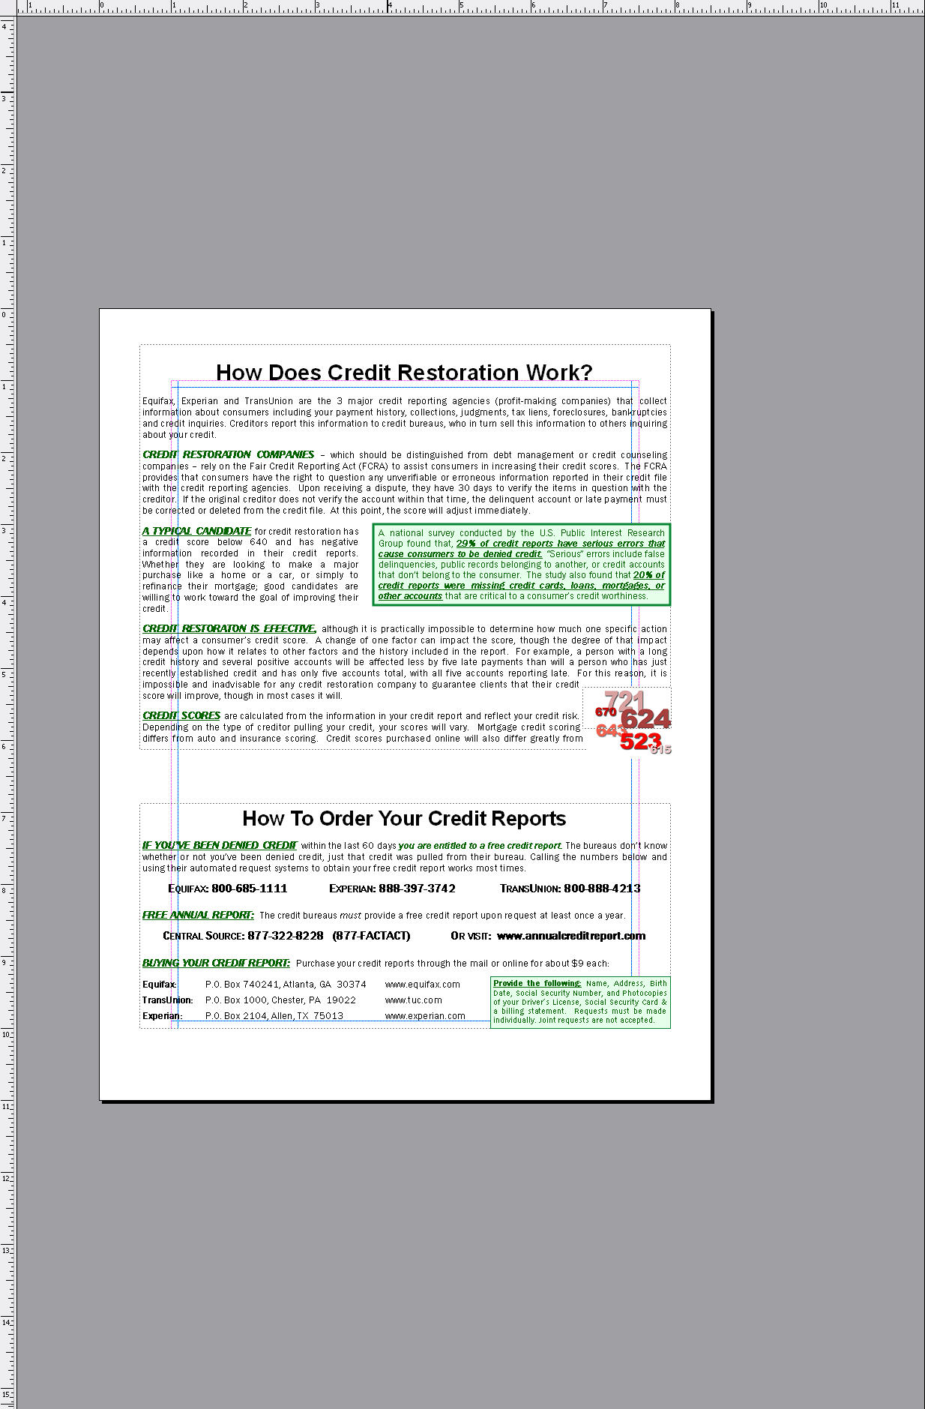
- Credit restoration is the process of removing derogatory items from your credit report, thereby increasing your credit score.
- I would like to direct your attention to the credit restoration Handout.
I know that some of you might be thinking, is this possible, or can anything be removed from my credit report? The answer is yes and yes.
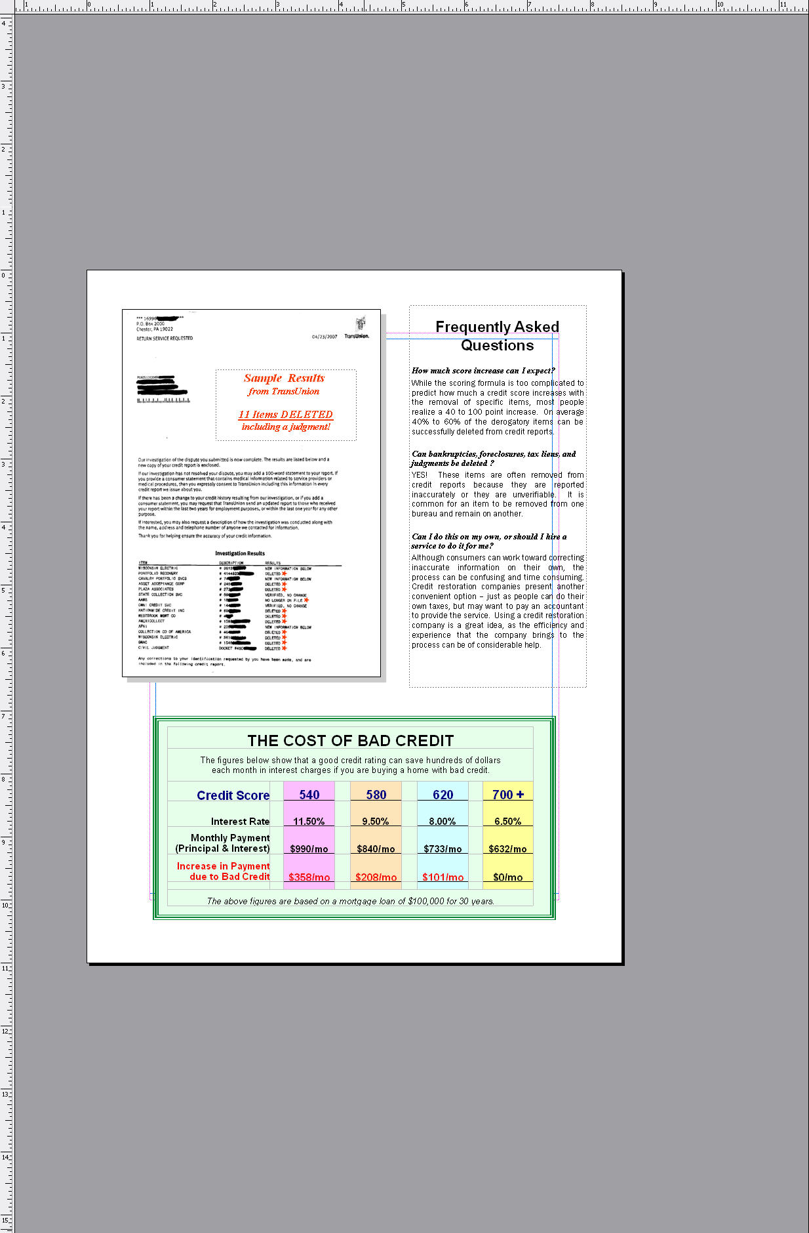
The credit restoration process can be summarized simply as:

Letters disputing your negative accounts are sent to the three credit bureaus. The bureaus are then required by the FCRA (Fair Credit Reporting Act) to contact the creditors of each of the disputed accounts and have them verify the information being reported. This must be accomplished within 30 days. Unverifiable accounts must be deleted from your credit report. Scores go up immediately.
- According to the Fair Credit Reporting Act (FCRA), it is your right to legally dispute any incorrect information on your credit report.
Credit Restoration is extremely effective for those needing to clean up their credit and obtain a vehicle, get insurance, refinance or buy a home.
- Typically in 3-6 months you can expect to see 40% - 60% of the derogatory information removed from your credit report…often increasing scores by 40 – 100 points.
- I’d like to direct your attention to the Opt-In Form; if you are interested in finding out more about Credit Restoration; please indicate it on the form.
- Another way to increase credit scores is to open new trade lines and pay them on time. This typically takes 6 - 12 months of on-time payments.
A credit report with no active, positive trade lines limits a score’s potential. A lender doesn’t put much stock in a credit card you were never late on 4 years ago. A lender is interested in how many accounts you are actively paying on-time today.
- If you have been denied for regular credit cards, look into getting a secured credit card.
A secured card requires a deposit that acts as collateral on the card in case you don’t pay the bill. Up to 100% of the amount you put down becomes the limit for that account. For example, if make a deposit of $500, you would be able to charge up to $500. Most secured cards come with fees, so check for the best deals.
- The more active trade lines you have, the better; also make sure to have various types of credit.
Having only revolving accounts, even though they are in good standing, will get the score only so high having installment accounts will get the score higher.
Identity Theft:
So far we’ve talked about managing and improving your credit.

Say that life is going great. Suddenly unexplainable bills are showing up on you doorstep, or worse, the police have issued a warrant for your arrest.
- “Identity theft occurs when someone uses your personal information without your permission to commit fraud or other crimes.”
- Most people don’t think it will happen to them.
- Unfortunately, it’s difficult for most people to relate.
Although some people are totally removed from the impacts identity theft has had on our society, many people have heard about data breaches that may have occurred, resulting in let’s say, 200 people getting their identity stolen, each losing about 500 dollars. The fact is that most people will never truly understand the gravity
- Nonetheless, by the end of this presentation, 16 people will have been victimized by identity theft. That’s just about everyone in this room. identity theft occurs every 79 seconds.
Let’s examine why this crime has become so prevalent.

No Where to Hide:
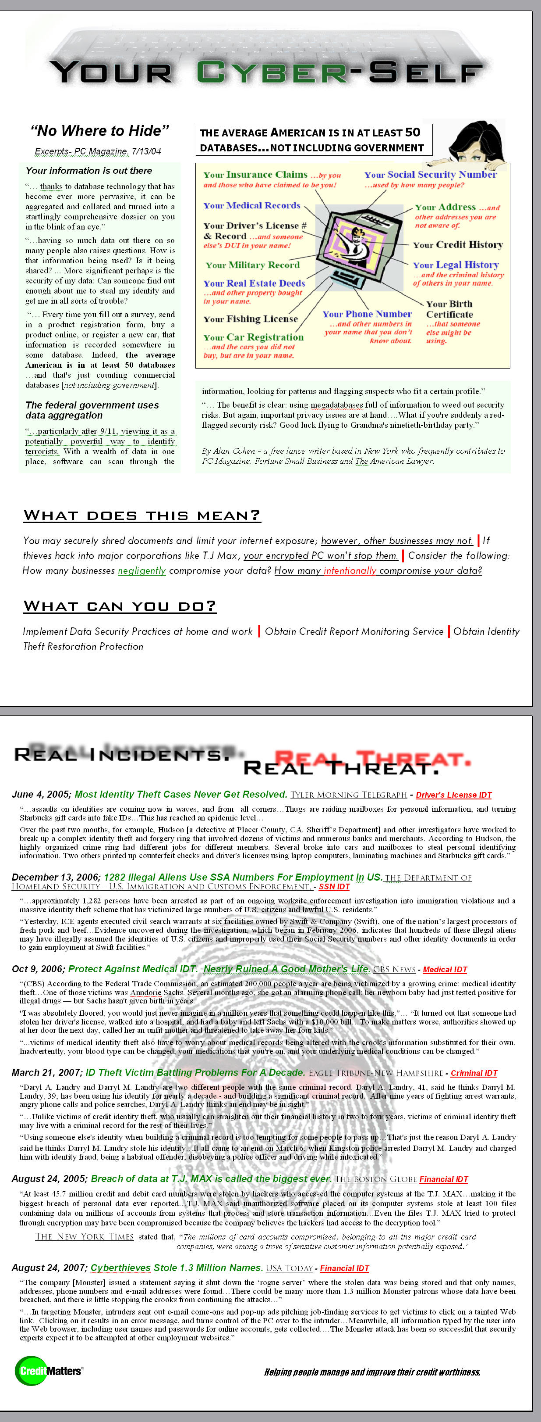
Re-printed here are excerpts from the article “No Where to Hide,” which talks about how our personal information is being held in numerous databases.
- In fact, according to the article, the average American is in at least 50 databases, not counting government databases.
- What does this Mean? You may securely shred documents and limit your internet exposure; however, places you do businesses with may not. If thieves hack into major corporations like T.J. Max, your encrypted PC won’t stop them.
Every time you apply for a loan, credit card, insurance, or job, you are required to fill out various forms with your personal identifying information. You are forced to trust your sensitive information in the hands of someone you have most likely never met. This is where problems occur—problems of identity theft.
Types of Identity Theft:
Generally, there are five types of identity theft that exist.
- Department of Motor Vehicles identity theft occurs when a thief uses your personal identity to get a driver's license.
- Social Security identity theft occurs when a person has stolen your SSN to gain employment or set up new accounts in your name at a different address.
- Medical identity theft happens when thieves use your identity to get prescription drugs or medical care.
- Criminal identity theft is when a thief uses your identity to impersonate you and commit a crime.
- Financial identity theft is when you find yourself obligated to pay expenses you never incurred.
Although most people associate identity theft with financial identity theft, it only accounts for 50% of all the identity theft going on. Please see the reverse side of the handout.
Real Incidents. Real Threat.
- You may feel disconnected with the amount of identity theft that is currently taking place, so i hope you realize there are real incidents that make identity theft a very serious and real threat.

Feel free to read through the excerpts in each article later in detail. If you can pay attention to the slides I will briefly summarize what happened and the victim impacts of each incident. Also notice the words in green after each title describing the type of identity theft that occurred.
- Most ID Theft Cases Never Get Resolved. Tyler Morning Telegraph. – 6/16/05 Driver’s License IDT
What Happened: People in a crime ring stole identifying information from mailboxes to print fake driver IDs.
Victim Impacts: Many counterfeit checks were written and thousands of $ were spent using victims’ names.
- 1282 Illegal Aliens Use SSA Numbers For Employment In US. U.S. Immigration and Customs Enforcement , the Investigative Arm of The Department of Homeland Security – 12/13/06. SSA # Identity Theft
What Happened: Crime organizations hijacked and sold US citizens’ SSA numbers to illegal aliens.
Victim Impacts: 1282 illegal aliens from Mexico and S. America used those SSA numbers to gain employment.
- Medical Identity Theft Nearly Ruined A Good Mother's Life. CBS News – 10/9/06.
What Happened: A woman stole the driver’s ID of Anndorie Sachs, walked into a hospital, had a baby, and left.
Victim Impacts: Authorities accused Sachs of being an unfit mother and threatened to take away her children. No one believed Sachs until she physically went and had her blood tested.
More Incidents. More Threat.
- ID Theft Victim Battling Problems For A Decade. Eagle Tribune. – 3/21/07 Criminal Identity Theft
What Happened: Darryl M. Landry used Daryl A. Landry’s identity to freely commit crimes. When abducting children, he had them call their parents, naming the innocent Daryl A. Landry as the culprit.
Victim Impacts: The innocent Daryl has been fighting angry phone calls and arrest warrants for nine long years.
- Breach of data at TJX could be the biggest ever. The Boston Globe – 3/27/07 Financial Identity Theft
What Happened: Thieves hacked into the system firewall to TJX and planted malicious software that stole data.
Victim Impacts: 45.7 million credit and debit card numbers were stolen. 8 million dollars was spent by thieves.
- Cyberthieves Stole 1.3 Million Names from Monster. USA Today – 8/24/07 Financial Identity Theft
What Happened: Thieves organized a massive operation that stole 1.3 million customer names & emails from Monster; they sent out an email that when clicked, allowed the thief to highjack the computer.
Victim Impacts: Many people have unknowingly granted thieves access to their personal information and will suffer identity theft.
Protect Your Identity:
One of the first steps you can take to safeguard your identity is:
- Pick up your mail immediately and never use your home mail box for outgoing mail, especially if you have one of those little red flags that can let a thief know a jackpot might be waiting inside.
- Make sure to shred or burn your personal documents.
- Placing a fraud alert on your credit file is free and upgrades the security against thieves stealing your identity.
When a fraud alert is put on all three credit bureaus, it “suggests” that a lender verify the individual’s identity before pulling credit.
- A security freeze is a stronger measure than a fraud alert, limiting anyone but you and your original creditors to having access to your credit file.
If you place a freeze, you will continue to have access to your free annual credit report. The cost is $10 per bureau to place and $10 to lift. It is free to victims of identity theft. The process to lift or set a credit freeze takes several days. It’s not immediate.
- The average victim spends 175 hours and $1000 restoring their name, which brings up “identity theft monitoring service” and “identity theft restoration service.”
Monitoring services offer daily notification to you, usually by email, when new accounts have been opened in your name. Restoration services help you restore your identity in the event you become victimized.

Everyone should obtain a copy of their free annual credit report to verify all personal and account information.

As of Jan 1, 2004 the FCRA now requires that all credit bureaus provide you one free credit report per year at www.annualcreditreport.com.
- If you would like to find out more information about how you can protect yourself from identity theft, just check it off on the opt-in form to discuss some solutions.

Thank You For Your Time!:
- Opt in Form
- If would like to receive more information about credit, please fill out the top half of the opt-in form to receive our newsletter.

- If you would like to personally meet and talk about a certain topic, please fill out the bottom half of the form.
While you are filling out this form I’ll be handing out the quiz answers and if you’d like, we can discuss anything you might have questions on.

Please return the forms to me at the front of the desk.
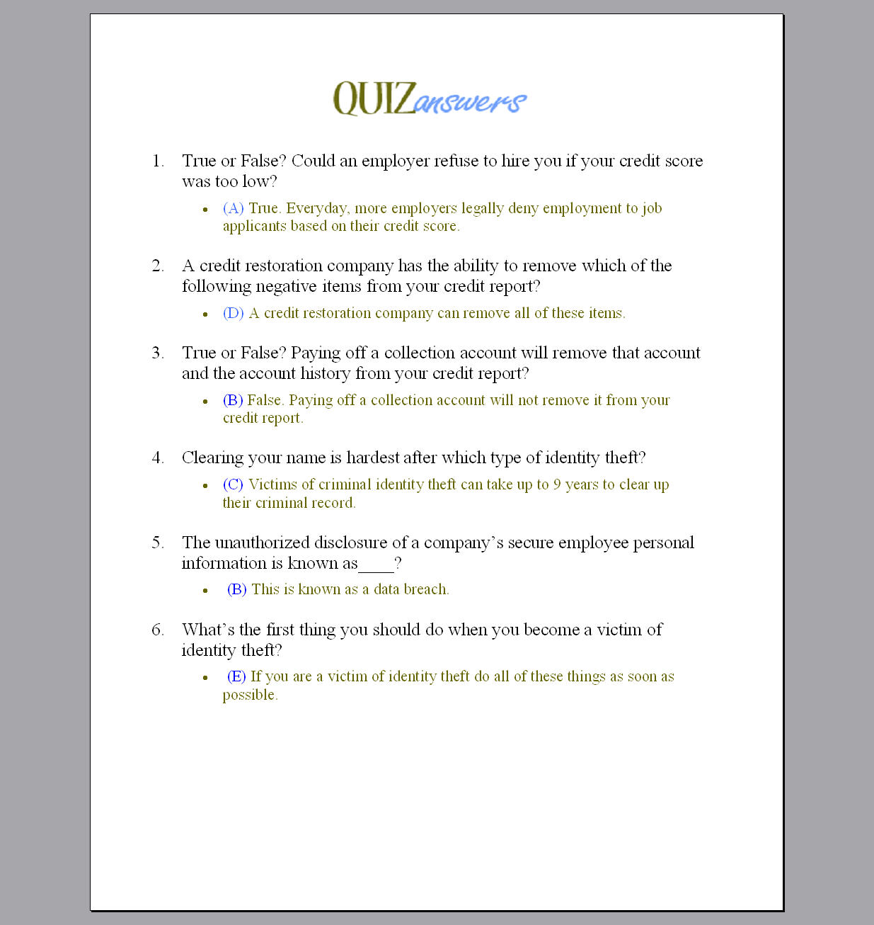
- Quiz Answers:
Now that you all have a greater understanding of credit and identity theft, I would like to briefly go over the answers to the quiz we took at the beginning of the presentation.
- 1. (C.) 720 is a very good credit score. 970 is not possible
- 2. (B.) Collections stay on a credit report 7 years after the date of last activity.
- 3. (B.) A utilization ratio over 30% reduces your score.
- 4. (C.) 30% of credit reports contain serious errors that result in the denial of credit.
- 5. (C) Computer hacking is the leading method of identity theft.
- 6. (A) (B) and (C). It is not considered identity theft “by a family member” unless you file a police report.

